**Name:Amirtha A  
Superset id: 6394120**

**1.GIT-HOL**

**Step 1: Setup your machine with Git Configuration**

To create a new repository, signup with GitLab and register your credentials

Login to GitLab and create a “GitDemo” project

1. To check if Git client is installed properly: Open Git bash shell and execute



If output shows Git with its version information that indicates, that Git Client installs properly.

1. To configure user level configuration of user ID and email ID execute



1. To check if the configuration is properly set, execute the following command.

**Step 2: Integrate notepad++.exe to Git and make it a default editor**

1. To check, if notepad++.exe execute from Git bash



If Git bash could not able to recognize notepad++ command that implies notepad++.exe is note added to the environment path variable.

To add path of notepad++.exe to environment variable, go to control panel -> System -> Advanced System settings. Go to Advanced tab -> Environment variables -> Add path of notepad++.exe to the path user variable by clicking on “Edit”

1. Exit Git bash shell, open bash shell and execute



Now, notepad++ will open from Git bash shell

1. To create an alias command for notepad++.exe, execute



It will open notepad++ from bash shell, and create a user profile by adding the line in notepad++



1. To configure the editor, execute the command



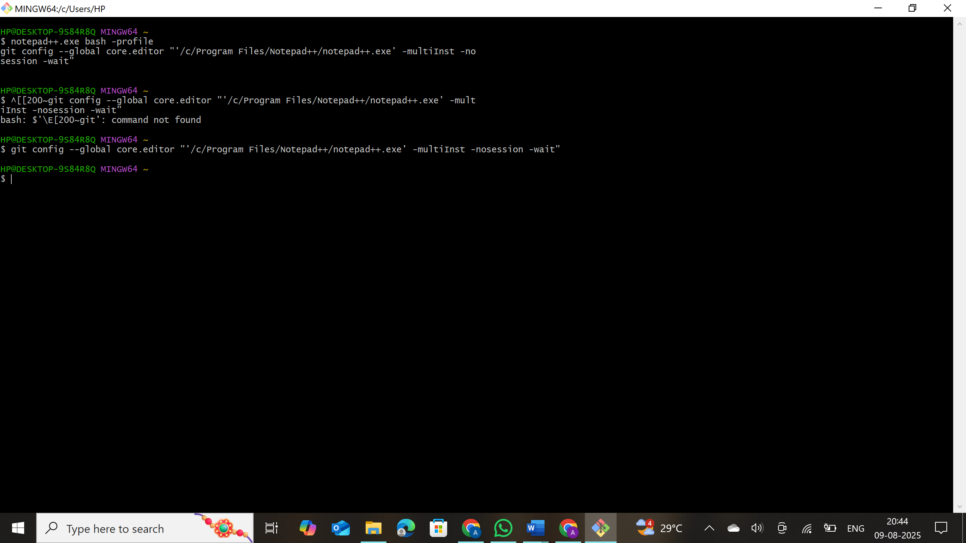

1. To verify if notepad++ is the default editor, execute the command



Here ‘-e’ option implies editor

It will show the entire global configuration as shown below,

**Step 3: Add a file to source code repository**

1. Open Git bash shell and create a new project “**GitDemo**” by executing the command



1. Git bash initializes the “**GitDemo**” repository. To verify, execute the command

It will display all the hidden files in the Git “working directory”.

1. To create a file **“welcome.txt”** and add content to the file, execute the command



1. To verify if the file “welcome.txt” is created, execute

1. To verify the content, execute the command



1. Check the status by executing

Now the file **“welcome.txt”** is available in Git “working directory”

1. To make the file to be tracked by Git repository, execute the command

1. To add multi line comments, we are opening default editor to comment. Execute the command



Notepad++ editor will open and to add multi-line comment with default editor

1. To check if local and “Working Directory” git repository are same, execute git status

**welcome.txt** is added to the local repository.

1. Signup with GitLab and create a remote repository **“GitDemo”**
2. To pull the remote repository, execute

git pull origin master

1. To push the local to remote repository, execute

git push origin master

